http://www.cs.utexas.edu/~scottm/uil/practiceMaterials.html
Link to the textbook
http://www2.lgisd.net/knapik/Lesson%20Plans/CScience/BPJ_TextBook_3_0_5.pdf
Link to the java videos
http://www.pvpusd.k12.ca.us/penhi/compsci/bluebook/menu1.htm
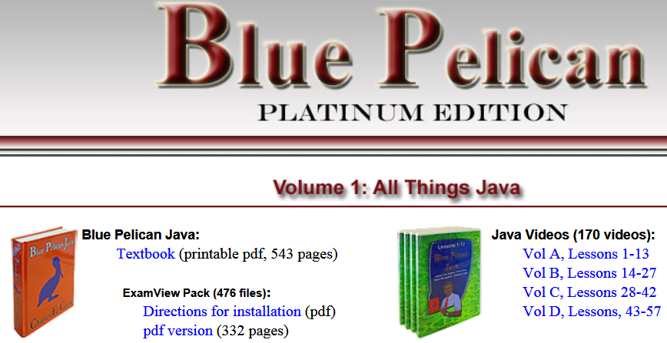

Graphical Labs
http://www.pvpusd.k12.ca.us/penhi/compsci/bluebook/BPJ%20Labs/menu.htm

